**Estimating pulse pressure variation in patients with respiratory muscle activity**

It is well known that volume status can be assessed from the variation in arterial blood pressure waveform. For patients with poor volume status the arterial wave form will have a second frequency due to ventilation, with the positive pressure ventilation reducing the preload of the right heart, while improving the function of the left heart. An example of this pattern is seen in figure 1.

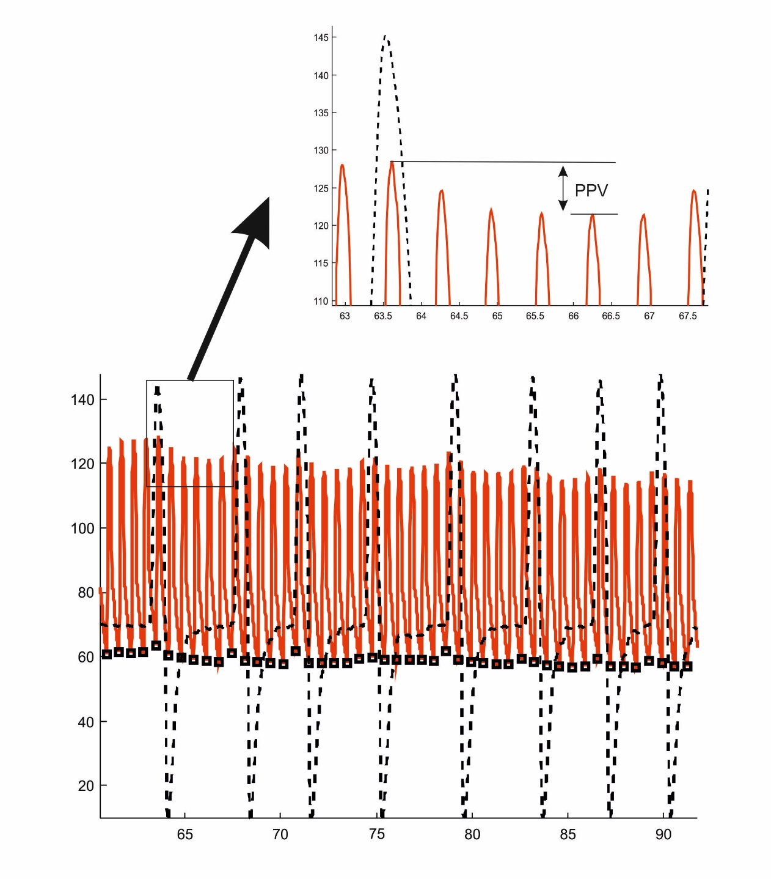

Figure 1 – Arterial blood pressure (red) and respiratory flow (black).

As shown on figure 1, during inspiration (peak positive flow) the positive pressure of the mechanical ventilation increases the blood pressure. During expiration, the relaxation of positive pressure in the lungs reduces the blood pressure. The height difference known as the pulse pressure variation (PPV), or numerous other variables derived from the shape of the blood pressure signal during positive pressure ventilation, are well known to be indicators of poor volume status. Taken together these indices are known as dynamic indices of hemodynamic status.

This invention addresses one of the major limitations of the assessment of PPV and similar indices, namely that when the patient begins to breath themselves then the contraction of the respiratory muscles during inspiration damp the blood pressure swing caused by positive pressure ventilation. In such circumstances it is understood that the PPV and other indices are no longer useful. As it is increasingly popular to lightly sedate patients, and maintain respiratory muscle activity, then the use of these indices in intensive care may be limited.

**Proposed invention**

The postulate of this invention is that the patients respiratory muscle activity can modify PPV and other indices in such a way that extra information on these indices can be obtained by variation of respiratory muscle activity. Is it suggested that changes in the level of pressure support ventilation in the same patient can augment the PPV signal and allow PPV and other indices to be used in situations of respiratory muscle activity.

Figure 2 illustrates data from a single patient mechanically ventilated at a pressure support level of 18 cmH2O. this is the data from the same patient and same conditions as figure 1. In this figure the magenta curve is the respiratory pressure measured at the mouth. The delivered pressure by the ventilator is high illustrated by a high magenta peak, and the patient effort is small, illustrated by a very small negative pressure swing (NPS) prior to the onset of respiratory flow.

The patient therefore closely approximates control mode and the PPV change is therefore as one would see in control mode ventilation.

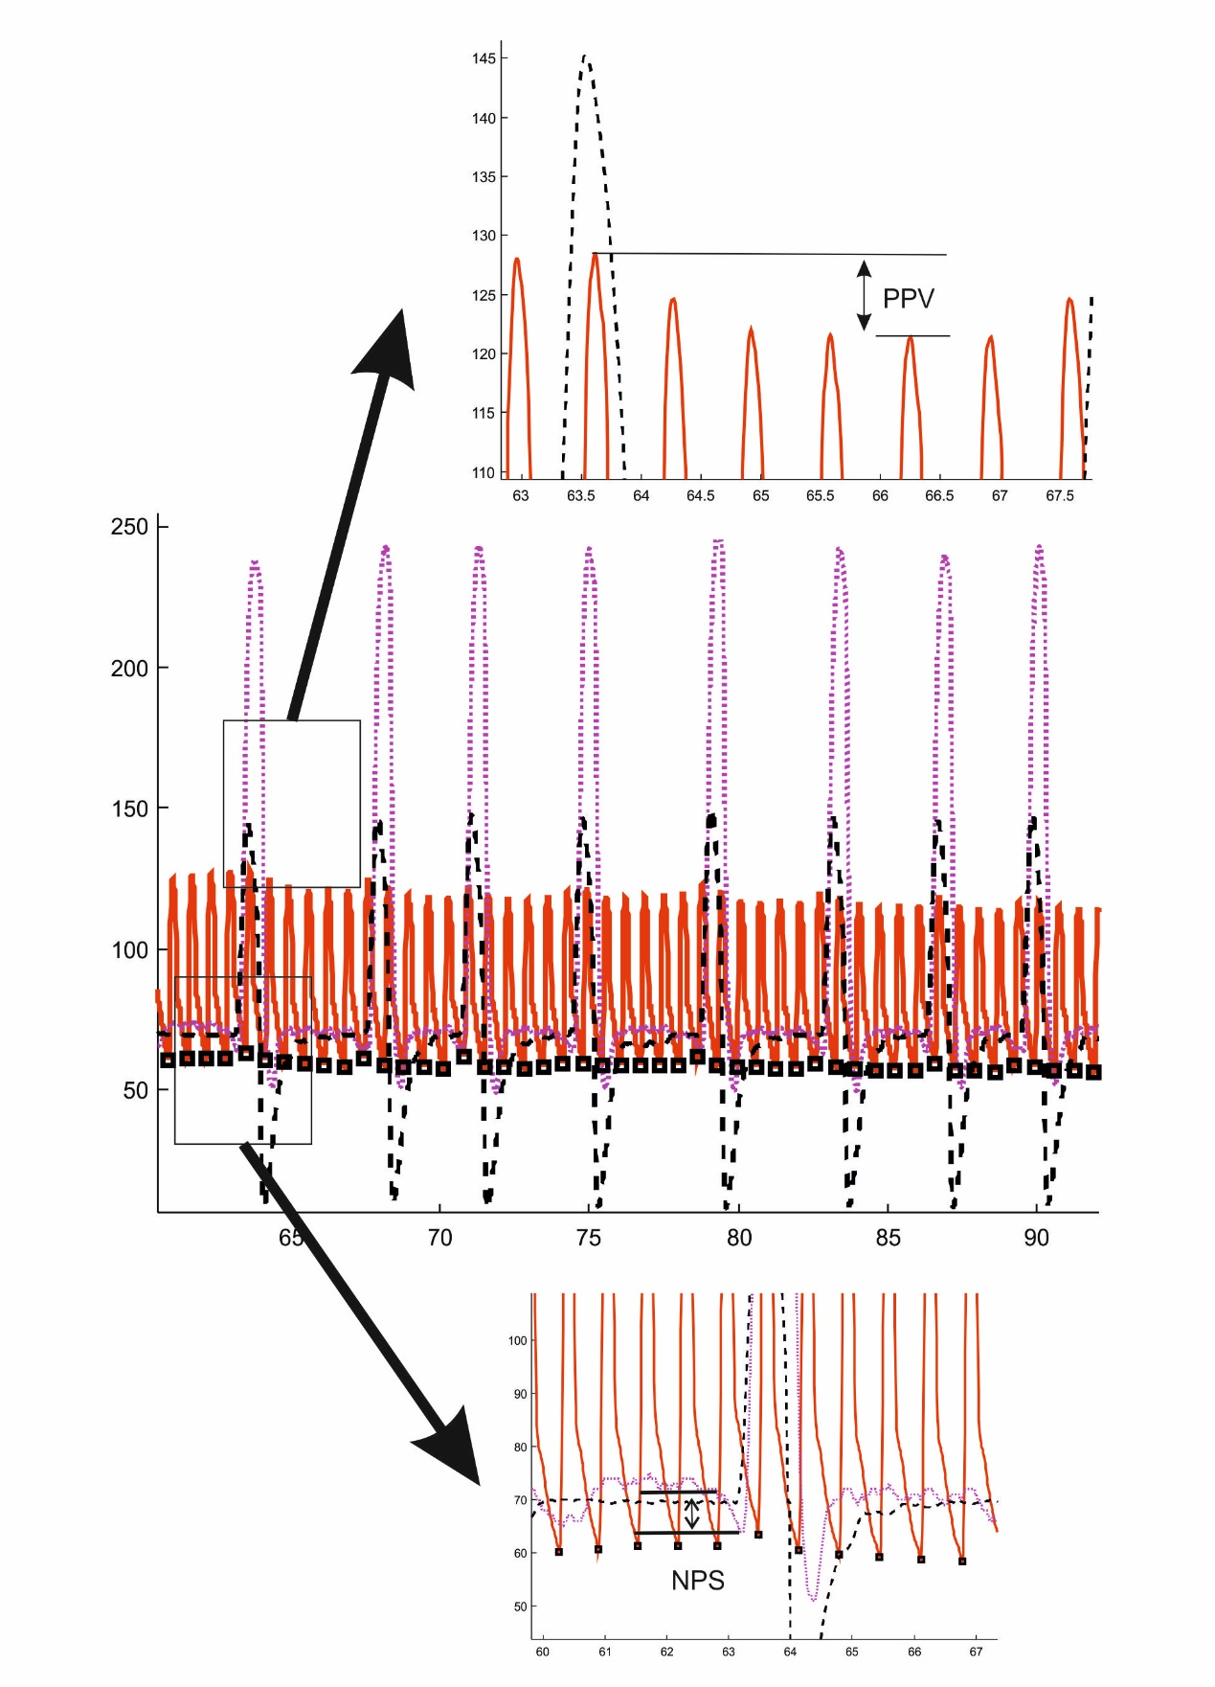

Figure 2 – PPV at PS 18 cmH2O

Figure 3 illustrates the same patient ventilated at a pressure support level of 2 cmH2O. The magenta line describing the pressure has a very low peak, and the patient is clearly working hard during the onset of ventilation with a very deep negative pressure swing (NPS). The PPV is now inverted with the lowest values during inspiration due to the negative thoracic pressure during inspiration due to the patient effort. The signal is not however lost, but rather complements that at high levels of PS.

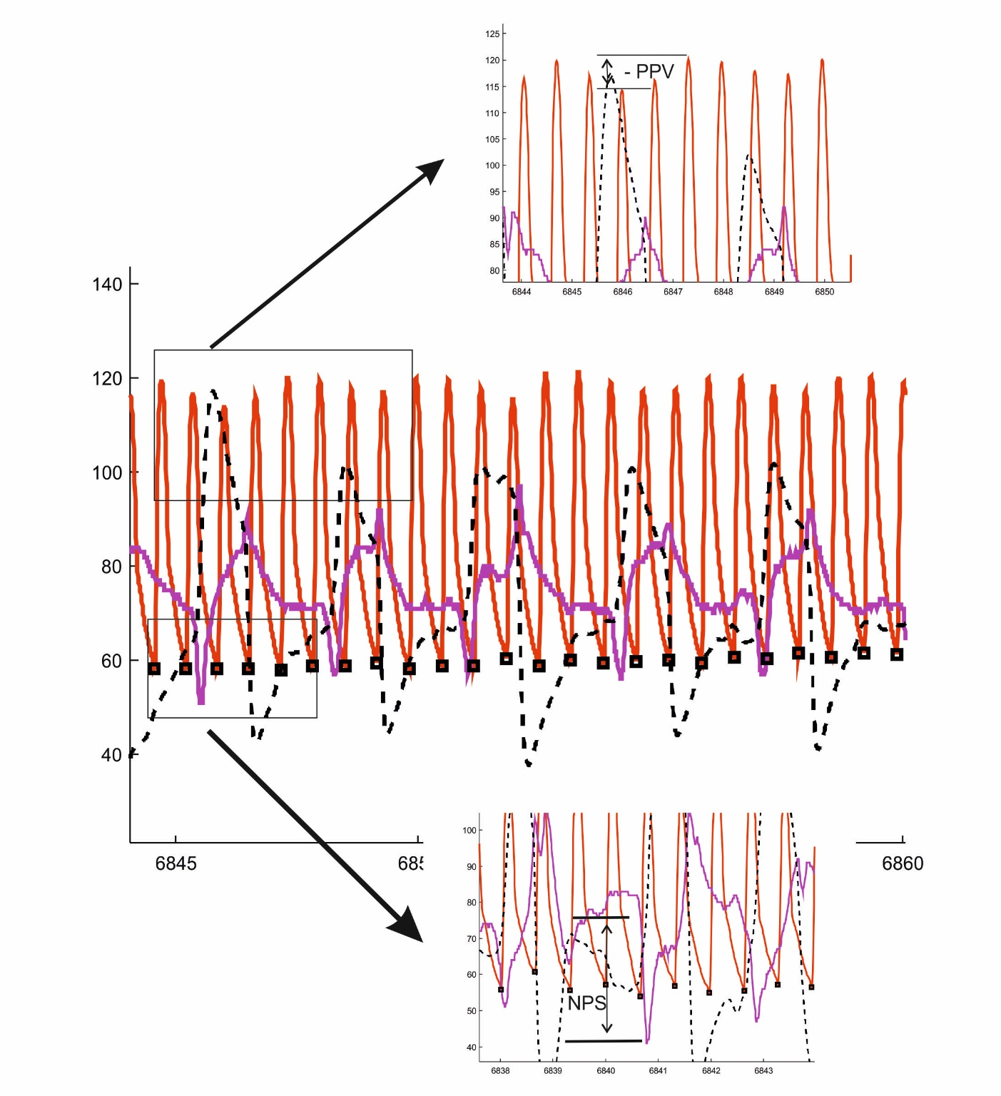

Figure 3 PPV at PS 2 cmH2O

If we call the inverted PPV at low pressure support ‘–PPV’, then it is possible to investigate how PPV and –PPV vary across a range of pressures support levels. This is illustrated in figure 4.

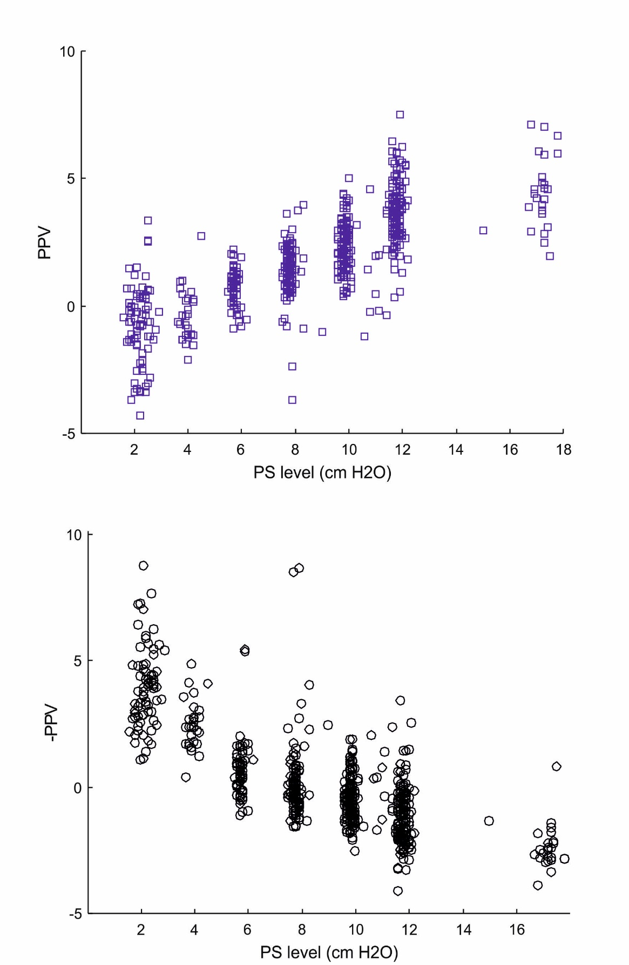

Figure 4 – positive PPV, and negative PPV in the single patient over a range of PS levels, each point represents a single breath

As illustrated in Figure 4, as PS is increased the –PPV disappears and we return to PPV. The total fluid responsiveness signal should however be the combination of the two at the highest and lowest PS levels, as both show that the patient’s arterial blood pressure is responsive to thoracic pressure changes.

The PS change has therefore effectively augmented the PPV signal, meaning that the limitation described, i.e. it not being possible to use in patients with respiratory muscle activity, has now been turned into a positive effect improving the signal. To implement this technique requires methods to identify if PPV of –PPV is the pattern and to define a strategy for variation of PS.